Appendix D
Public Engagement Portal Feedback

Harrow Street Spaces Map

The Harrow Street Spaces Map asked visitors to identify areas on a map that were a problem, to explain the issues and to indicate possible solutions. Comments were received widely across the borough as shown in the map below. The following question was asked. Chart 1 shows the results.

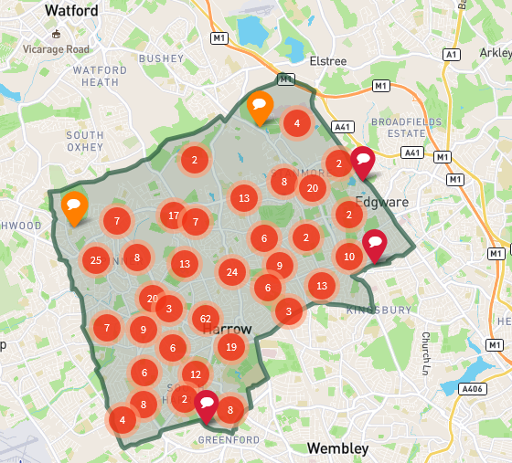 | 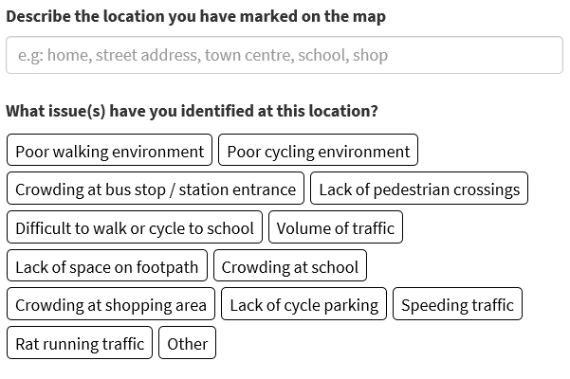
The following questions were asked about possible solutions and views about making solutions permanent. Charts 2 and 3 shows the results.
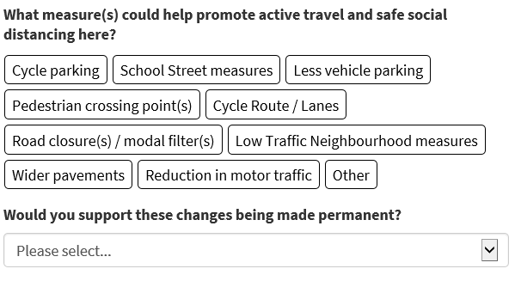
Questions were also asked about how comfortable people felt about walking and cycling. Charts 4 and 5 provide the results.

Harrow Street Spaces Proposals
The Harrow Street Spaces Proposals website provided information and detailed plans about the specific schemes developed in four different categories and gave a option to provide comments. The categories are:

- Low traffic neighbourhoods
- Pedestrian space measures
- School Streets
- Strategic Cycling
The responses have been assessed based on people living in the directly affected areas via their postcode and where responses have been confirmed.

For low traffic neighbourhoods the following options were available on the form. The responses are shown in chart 6.

For school streets the following options were available on the form. The responses are shown in chart 7.
For strategic cycling schemes the following options were available on the form. The responses are shown in chart 8.

For pedestrian space measures the following options were available on the form. The responses are shown in chart 9.

